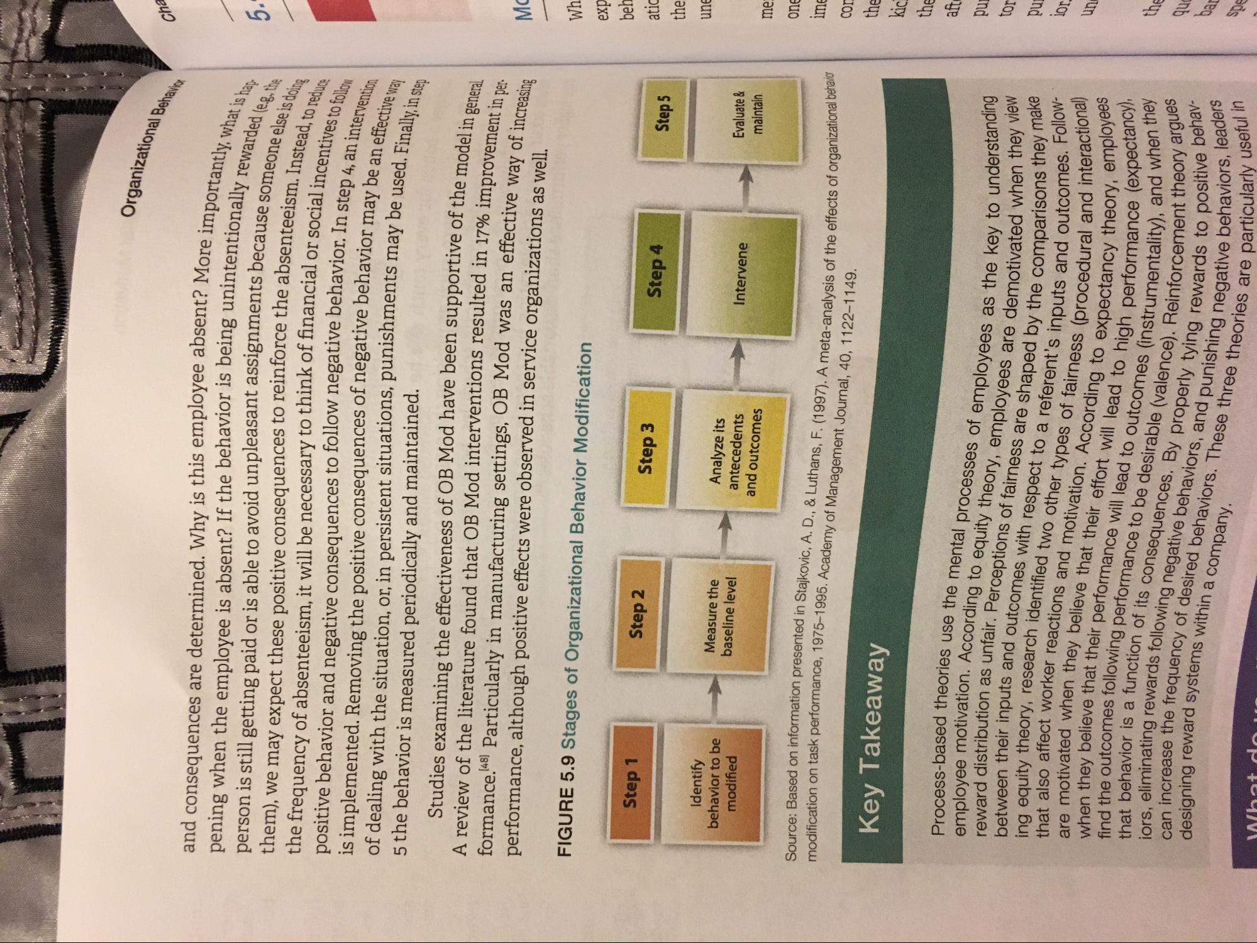
Organizational Behav
Cha
ore importantly, what is han
e unintentionally rewarded les
and consequences are determined. Why is this employee absent? More impo pening when the employee is absent? If the behavior is being unintentionally ro person is still getting paid or is able to avoid unpleasant assignments becauses them), we may expect these positive consequences to reinforce the absenteeism the frequency of absenteeism, it will be necessary to think of financial or social in positive behavior and negative consequences to follow negative behavior. In sten is implemented. Removing the positive consequences of negative behavior may be an of dealing with the situation, or, in persistent situations, punishments may be used. Fir 5 the behavior is measured periodically and maintained.
Studies examining the effectiveness of OB Mod have been supportive of the model; A review of the literature found that OB Mod interventions resulted in 17% improvem formance..48) Particularly in manufacturing settings, OB Mod was an effective way of inen performance, although positive effects were observed in service organizations as well.
because someone else is doina
nteeism. Instead, to reduce lor social incentives to follow or In step 4, an intervention or may be an effective way ay be used. Finally, in step
ve of the model in general. 17% improvement in per
Wh
FIGURE 5.9 Stages of Organizational Behavior Modification
Step 1
Step 2
exp beh atic
Step 3
Step 4
Step 5
the
une
Identify behavior to be
modified
Measure the baseline level
Analyze its antecedents and outcomes
Intervene
Evaluate & maintain
me
one
Source: Based on information presented in Stajkovic. A.D modification on task performance. 1975
ime
A meta-analysis of the effects of organizational behavior
ormation presented in Stajkovic, A. D., & Luthans, F. (1997). A meta-analysis of the e ook performance, 1975-1995. Academy of Management Journal, 40. 1122-1149.
Key Takeaway
s as the key to understanding demotivated when they view
ake
Process-based theories use the employee motivation. Acco reward distribution as unfair between their inputs and outcomes ing equity theory, research i that also affect worker reactions an are motivated when they when they believe that the find the outcomes following that behavior is a funct iors, eliminating reward can increase the frequen designing reward system
ess-based theories use the mental processes of emplovees as the key to unde lovee motivation. According to equity theory, emplovees are demotivated w distribution as unfair. Perceptions of fairness are shaped by the comparisons
nputs and outcomes with respect to a referent's inputs an eory, research identified two other types of fairness (procedural not worker reactions and motivation. According to expectancy
d when they believe that their effort will lead to high performans ey believe that their performance will lead to outcomes (instrumentality), ar outcomes following performance to be desirable (volonnel Deinforcement the
un
nts inputs and outcomes. Followless (procedural and interactional)
tancy theory, employees to high performance (expectancy
hentality), and when they
ole (valence). Reinforcement theory a
vior is a function of its consequences. By properly tving rewards to a reward systems within a company.
ating rewards following negative behaviors, and punishing negative e se the frequency of desired behaviors. These three theories are par
wards to positive behavlegative behaviors, leaders
re particularly useful in
What do

